**Excel To Points Tool:**

When in ArcGIS Pro, navigate to the catalog page. It's on the right side of the window by default.

Right click on the Toolboxes and click on “Add Toolbox.” This will take you to the file exploring window.

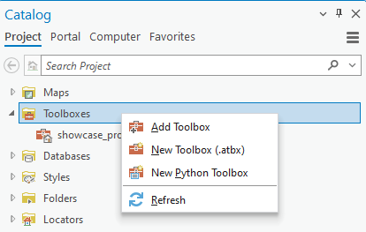

Navigate to where the saved Toolbox files are located. These toolbox save as a .pyt

Click on ToPointsTool.pyt and then click OK.



This Toolbox is now in your project and ready to be used.

Click on the arrow on the left side of the toolbox to open the various tools associated with this toolbox. The two different tools are named “Excel to Points Tool” and “NetCDF to Points Tool.”

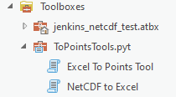

Excel to Points Tool:

Here is what the toolbox looks like when first opened.

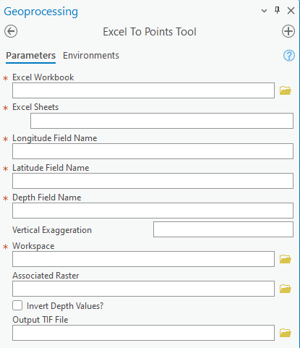

This document will describe each of the inputs that is accepted with the tool, but if a refresher is needed on the input by hovering over the little blue ‘i’ icon, it will give a brief description of each of the inputs within the tool.

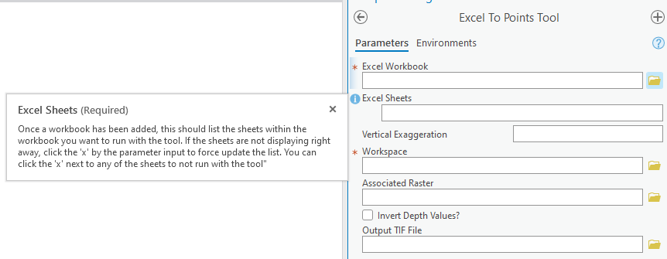

Click on the folder Icon on the right side of the parameter named “Excel Workbook”

It’ll accept only files that end with either .XLS or .XLSX.

Click on the file you want to add and the hit OK

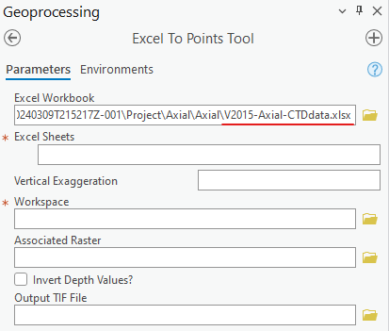

This demo will use the file “V2015-Axial-CTDdata.xlsx”

If the sheets of the document do not show up right away, click on the red ‘x’ on the left side of the parameter window. This should refresh the tool and populate the field with the various sheets within the excel workbook file.

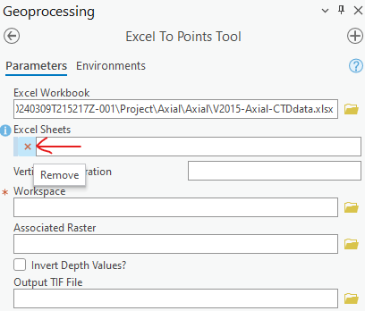

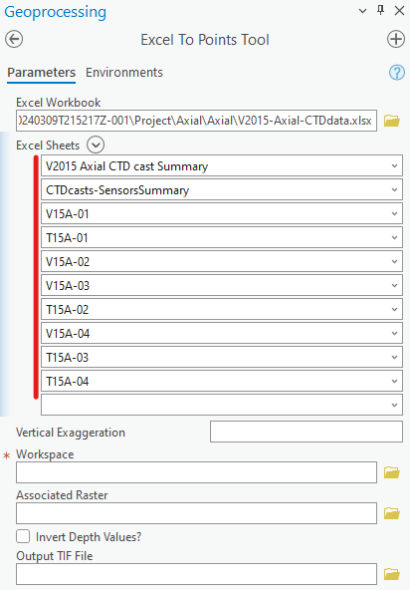

We are not gonna want to work with the two sheets “V2015 Axial CTD cast Summary” or “CTDcast-SensorsSummary,” so we will remove them by clicking the red x to the left of their names.

For the fields, Longitude Field Name, Latitude Field Name, and Depth Field Name. Select the columns that you want to be using each of the associated fields.

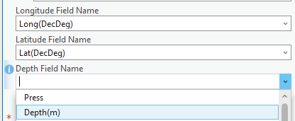

In “Vertical Exaggeration” input 5 as this will manipulate the drawing location of where the points are drawn in the default projection system.



Adding the vertical exaggeration to the points is important if the goal is to upload and showcase these points in an ArcGIS Online environment. Currently, ArcGIS Online does not have a native way to manipulate the Vertical Exaggeration of the points, so it must be done prior to upload.

Workspace is the output destination for the files being created with the tools. For this demo, “showcase_database.gdb” is chosen as the workspace.



With Axial, there is access to a Multibeam_Mosaic TIF file that has a higher resolution than some of the TopoBathy basemap layer found within the ArcGIS Online database. These TIF files will also need to have vertical exaggeration applied to them in ArcGIS Pro before being uploaded into an ArcGIS Online environment. This parameter does not require an input for the tool to run successfully, but for the demo will run with the file “Axial_Multibeam_Mosaic_1.tif”



Knowing how our data is stored within the excel worksheet is important for the next parameter “Invert Depth Values?” For our default projection positive depth values will show as distance above sea-level, where negative will be below. In this particular file our column of ‘Depth(m)’ values is positive, so it would be appropriate to check the box to properly draw the points below sea-level.



The final parameter will be the name of the output TIF file that will be created if an input TIF file was given in the “Associated Raster” parameter. For this demo, the file is named “show_tif_file” ; it will be given an appropriate ___ and selected the “showcase_database.gdb” as the destination for this file.



Here is what the final inputs look like before it’s ready to run.

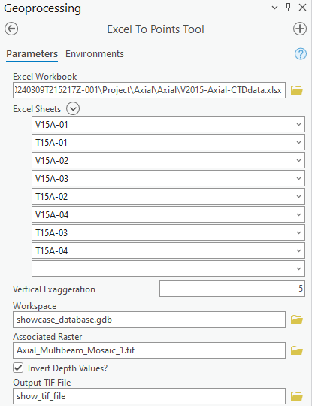

Click Run at the bottom of the geoprocessing pane to run the tool.

If no problem occurred with the run, a successful message should appear.



Navigating to our database we selected as our workspace, we should see that each worksheet has been successfully converted into a points File Geodatabase Feature Class.

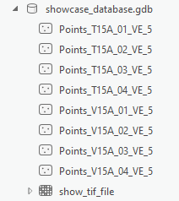

The naming convention is “Points_(Name of the Excel Sheet)_VE_(Vertical Exaggeration Input)”

These files were properly named “Points_(Name of the Excel Sheet)_VE_5”

The modified raster is also within the file geodatabase.

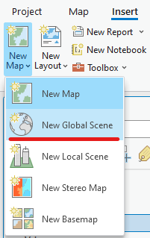

To see the files in a 3D view output, we need to create a new global scene.

Navigating to the Insert Tab, on the far left under “New Map” click on “New Global Scene”

Highlight all the files from the geodatabase and drag them over to the new scenes Contents Page.

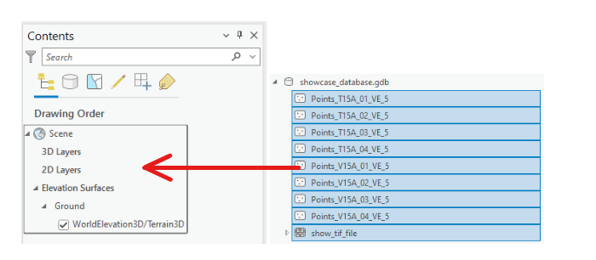

Navigating in the scene, we see that the points are going beneath our raster layer

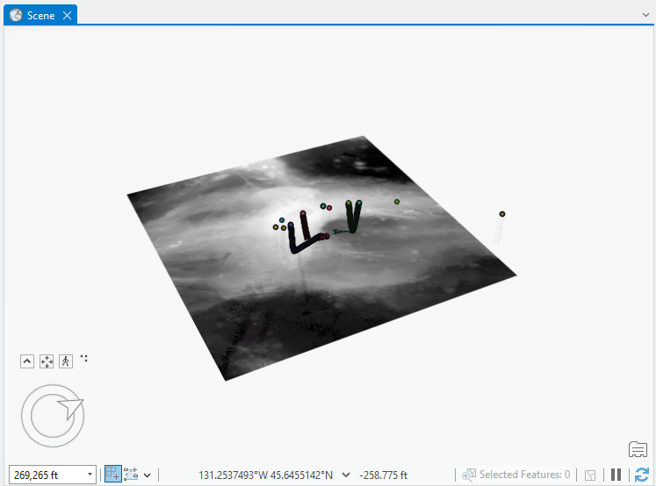

In the contents panel, navigate to the bottom where it says “2D Layers” and “Elevation Surfaces.” The raster is displayed as a 2D surface, to fix this drag the layer into the ‘Ground’ section under “Elevation Surfaces” and it should display a 3D version of the raster layer.

Adding an additional “Axial_Multibeam_Hill.tif” to the scene contents layer for some color. We have now successfully created vertically exaggerated File Geodatabase Feature Class points for each of our sheets within our chosen excel workbook and displayed them in a Scene View.

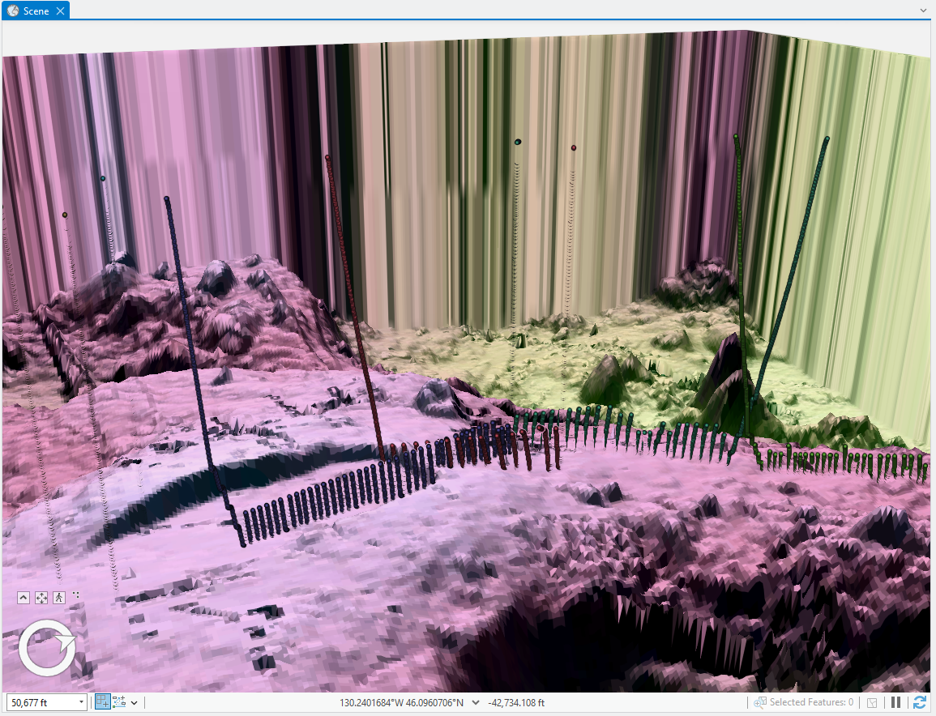

These raster files are high resolution, so rendering them takes a long time. That is why you’ll see the ends of the raster having a difficult time loading and rendering properly within the scene view itself.

**NetCDF to Excel**

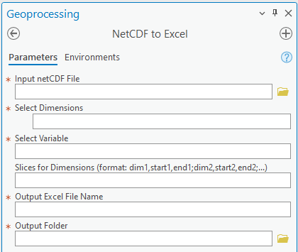

Okay, for the input you want to navigate to your netCDF file that you want to use.

For this we will be using the Tritium_Helium_Jenkins-Compilation.nc

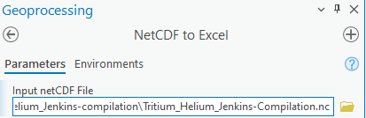

Once your file is selected, the Select Dimension should auto populate with values of the dimension in the file. In this case our two dimensions are N_STATIONS and N_SAMPLES

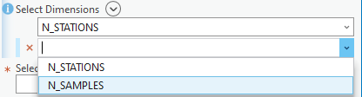

After the dimensions are selected, the Select Variable field will auto populate with values from the first dimension selected. This will take the first value from this variable field and use that to name our Excel Sheet, as we will see later. In this case, we will be selecting ‘metavar2’



The next one will require proper syntax to be able to execute the tool. This will be taking certain sections of the dimensions, to limit our output in the case we do not want to process the entire file. In our case we will be selecting the first 25 stations.



We will now name our excel sheet and select a location to save the file.

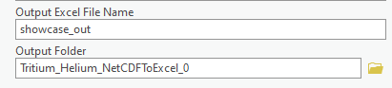

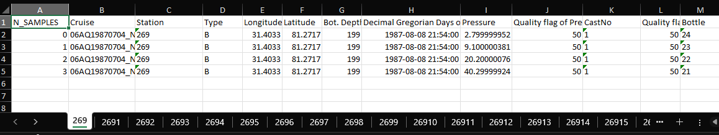

Here is an example of the output Excel file. The names of the sheet will be the value of the variable that we selected.

***There is a portion within the code that directly references some of the output columns within the Jenkins netCDF. If using a different netCDF, you will have to change and update this section of the code for it to run correctly. ***

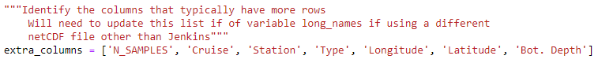

You can then use this new Excel file and the other tool to create a point feature class.